**Assignment 10.1: Milestone #2**

Joshua Kelbley, Louis Capps

Group 3 Willson

Bellevue University

CSD310: Database Development and Use

Professor Darren Osier

3 December 2023

Revised ERD:

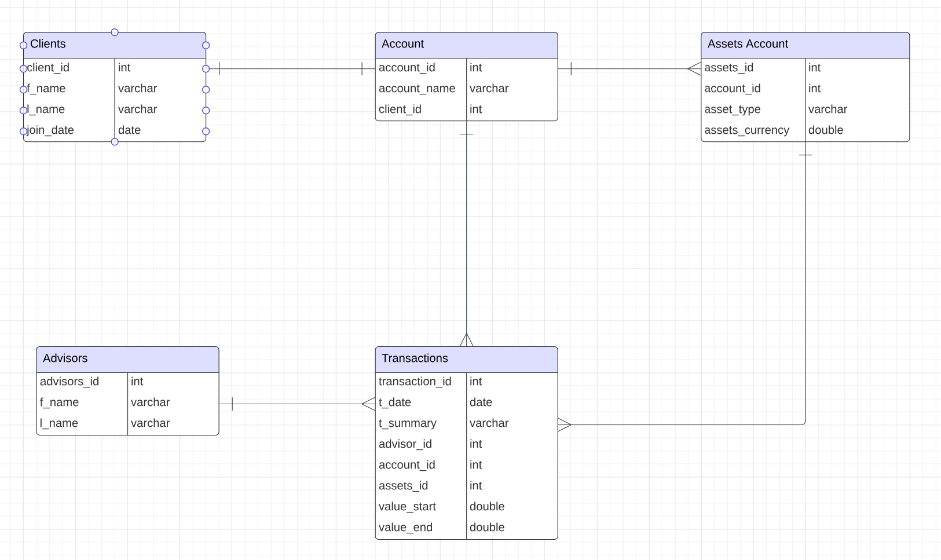

Louis table data displayed:

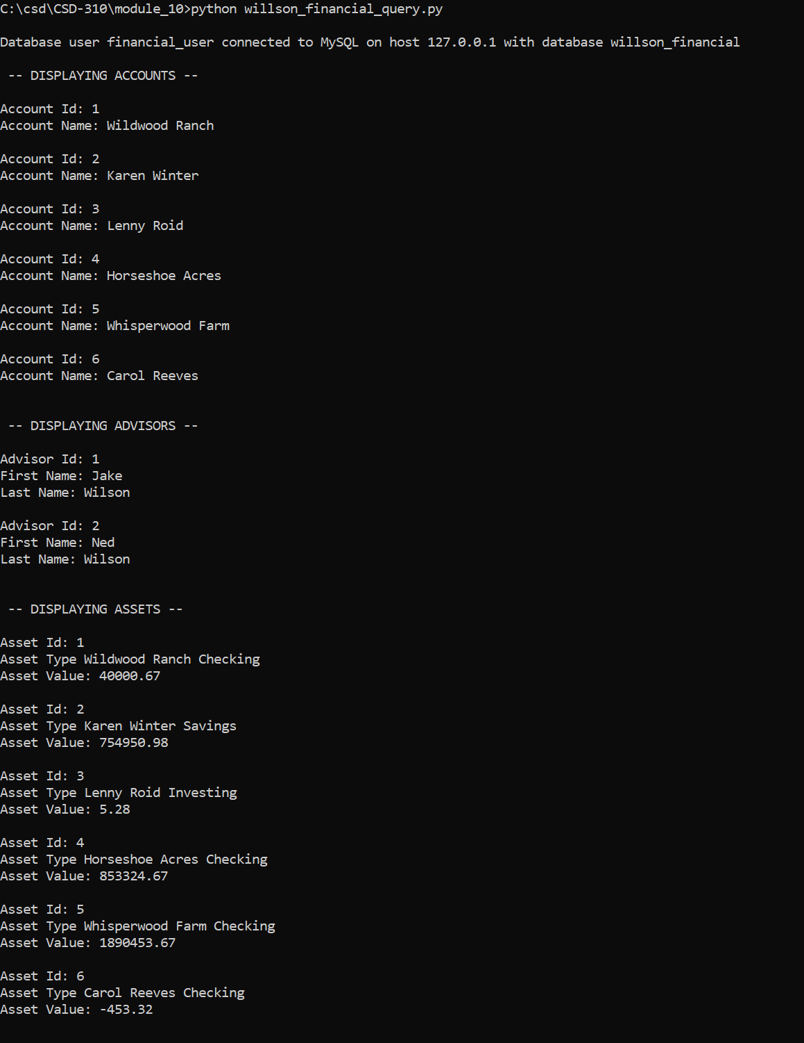First image

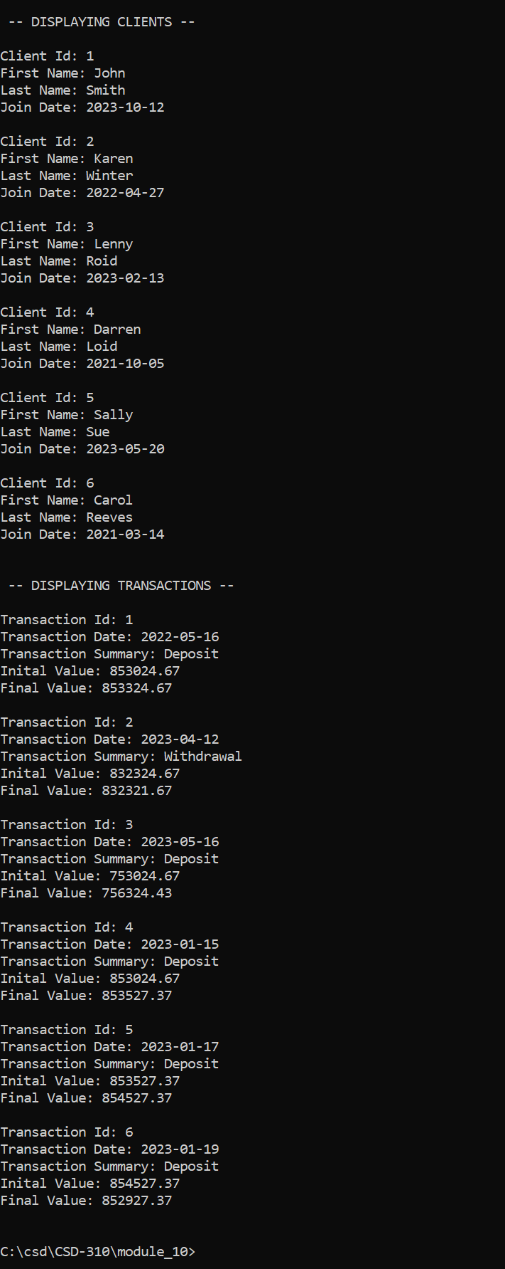Second image

Joshua table data displayed:

